(E2.4) A laser printer uses a laser beam to print copy rapidly for a computer. The laser is positioned by a control input r(t), which represents the desired position of the laser beam.

1. If r(t) is a unit step input, find the output y(t).
2. What is the final value of y(t)?

Ans.

1. Unit step input 🡪 , then we have.

The partial fraction expansion.

Using the Laplace transform, we find that.

1. The final value is computed using the final value theorem:

(E2.6) A nonlinear device is represented by the function, where the operating point for the inputis. Determine a linear approximation valid near the operating point.

Ans.

Linear approximation is , where. Therefore, we obtain the linear approximation.

(E2.8) A control engineer, N. Minorsky, designed an innovative ship steering system in the 1930s for the U.S. Navy. The system is represented by the block diagram shown in Figure E2.8, where Y(s) is the ship's course, R(s) is the desired course, and A(s) is the rudder angle. Find the transfer function Y(s)/R(s).

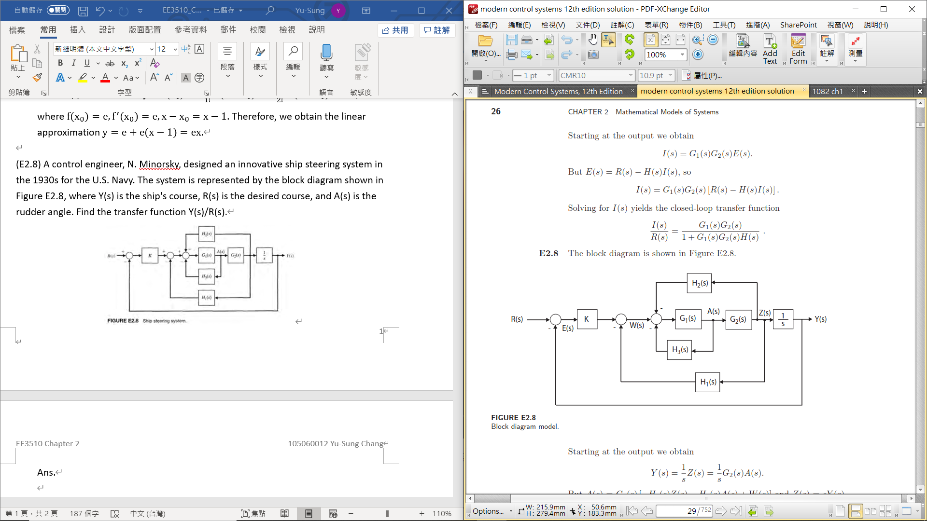

Ans.

…

(E2.16) The position control system for a spacecraft platform is governed by the following equations:

The variables involved are as follows:

= desired platform position, = actual platform position, = amplifier input voltage, = amplifier output voltage, = motor shaft position

Sketch a signal-flow diagram or a block diagram of the system, identifying the component parts and determine the system transfer function P(s)/R(s)

Ans.

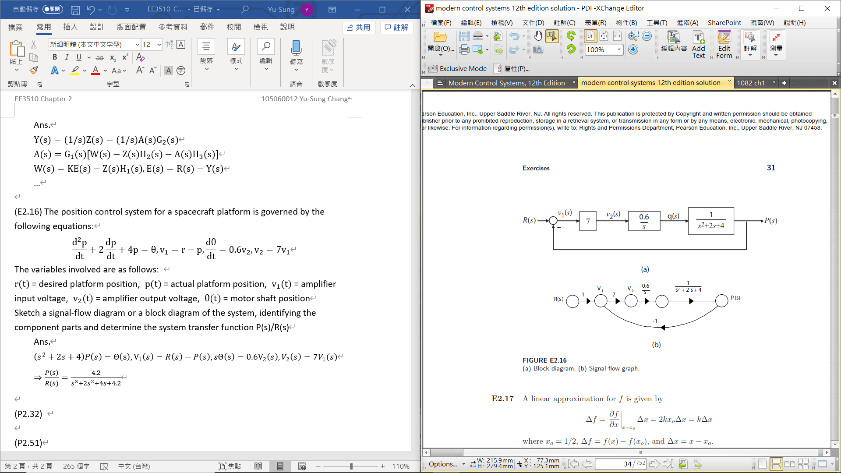

(P2.32) A system consists of two electric motors that are coupled by a continuous flexible belt. The belt also passes over a swinging arm that is instrumented to allow measurement of the belt speed and tension. The basic control problem is to regulate the belt speed and tension by varying the motor torques.

An example of a practical system similar to that shown occurs in textile fiber manufacturing processes when yarn is wound from one spool to another at high speed. Between the two spools, the yarn is processed in a way that may require the yarn speed and tension to be controlled within defined limits. A model of the system is shown in Figure P2.32. Find, Determine a relationship for the system that will makeindependent of.

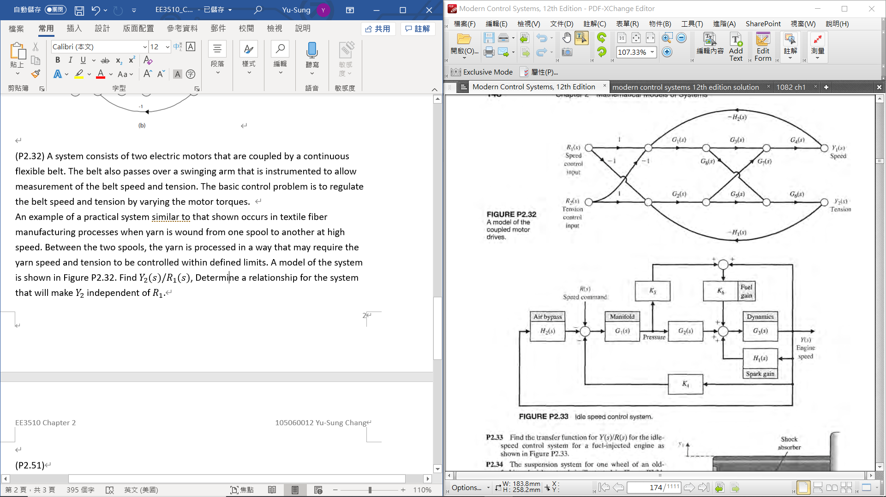

Ans.

(Three Loops)

(Transfer function)

Since we wantto be independent of,

We require

(P2.51) Consider the two-mass system in Figure P2.51. Find the set of differential equations describing the system.

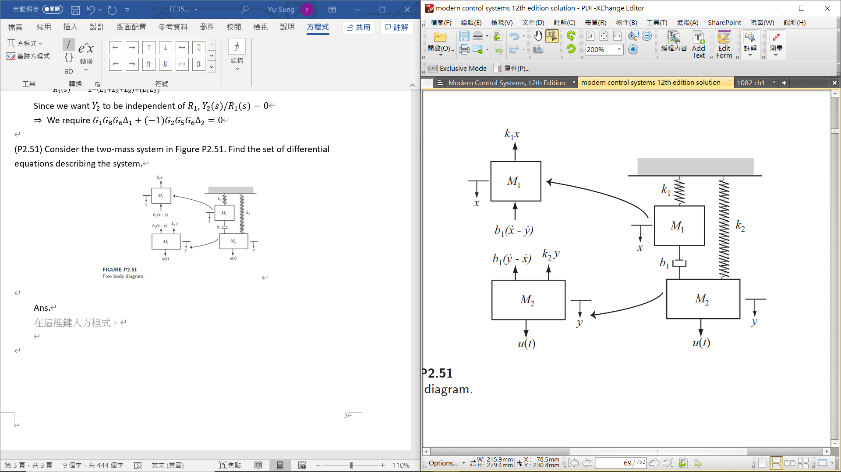

Ans.